**HOSPITAL MANAGEMENT SYSTEM**

MINI PROJECT IN DBMS

BY

(GROUP B23)

Mr. AFSAR H. A. SHEIKH (1725)

Ms. PRANITA S. SAWANT (1724)

OF

SECOND YEAR MCA

2018-2019

UNDER GUIDANCE OF

MS. YMA PINTO

(DEPARTMENT OF COMPUTER SCIENCE)

GOA UNIVERSITY

***CERTIFICATE***

***Certified that this project is a record of work by the candidates themselves during the period of study under my guidance, to the best of my knowledge and that it has not previously formed the basis of the award of any Degree or Diploma in the Goa University or elsewhere.***

***____________________***

***Ms. Yma Pinto***

***(Project Guide)***

***Goa University***

***DECLARATION***

*We declare that this project report has been wholly composed and compiled by us and has not been the basis for award of any degree or diploma in Goa University or elsewhere.*

*SYMCA.*

*(Computer Science)*

__________________ ________________

PRANITA SAWANT AFSAR H. A. SHEIKH

(1724) (1725)

**ACKNOWLEDGEMENT**

The satisfaction that accompanies the successful completion of any task would be incomplete without the mention of people whose ceaseless cooperation made it possible, whose constant guidance and encouragement crown all efforts with success.

We are extremely grateful to our Project Guide, **Ms. Yma Pinto** for being a source of inspiration and for her constant support in the development and implementation of this project. She have been a constant source of inspiration and motivation for hard work. We also would like to thank our batchmates as their inputs helped us to develop a good design for this project. Through this column, it would be our outmost pleasure to express our warm thanks to them for their encouragement, co-operation and consent without which we would not be able to accomplish this project.

**CONTENTS**

|  |  |  |
| --- | --- | --- |
| Sr. No. | Topic | Page No. |
| 1 | Introduction | 6 |
| 2 | Objectives | 7 |
| 3 | ERD | 8 |
| 4 | Users | 9 |
| 5 | Registration | 16 |
| 6 | Appointment | 17 |
|  |  |  |

**INTRODUCTION**

Hospitals play a major role in a human's life. There are several other reasons that a person needs medical assistance. And, to provide best medical assistance, the management of the hospital must be disciplined, well-versed in its service providing techniques.

We are designing a backend database for multispecialty hospital that will be used with web portal.

Any multispecialty hospital includes a number of departments, rooms, doctors, nurses, and other staff working in the hospital.

The main aim of this system is to design and develop a database for the hospital to maintain the records of various departments, rooms, and doctors in the hospital.

It also maintains records of the patients, patients admitted in the hospital, keeps the record of doctor who gave treatment to patients and the patients that have been operated, and patients discharged from the hospital.

OBJECTIVES

* **Computerization** - All the details regarding hospitals, whether it is small or big, will be computerised.
* **No redundancy** - For every test that is conducted of the patients, an automated report will be generated and will be available to the patients and his / her concerned doctor uniformly.
* **Keep the Records**– It will be easier task for the management to keep the record of the patients for historical purpose.
* **Appointment**– It will be easier for both the doctors and the patients to have the appointments.

**ERD**

[link_to_erd](erd.jpg)

**SYSTEM USERS**

The detailed functionality of each users viz. Admin, Hospital Staff and Patient are specified below:

**Admin:**

Profile

* Should login with the correct login id and password.
* 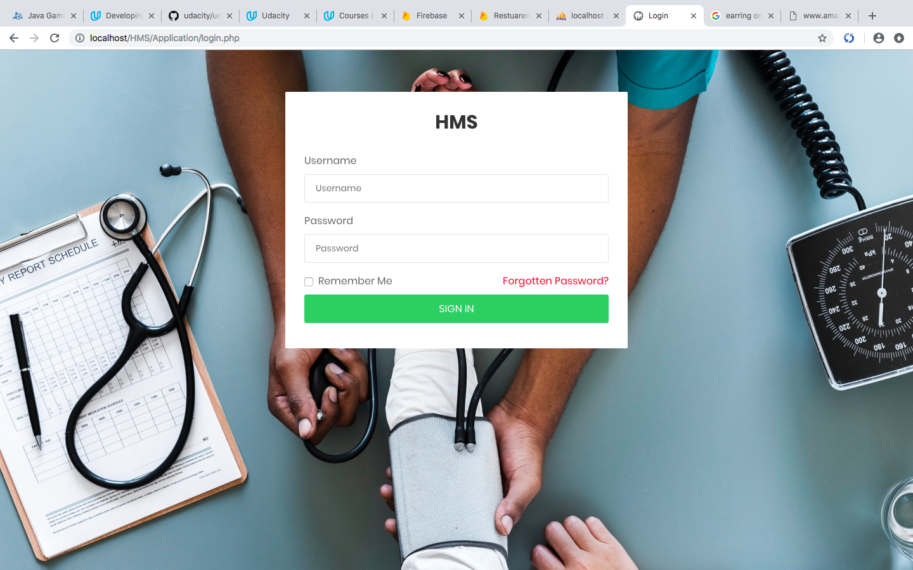Logout.

Dashboard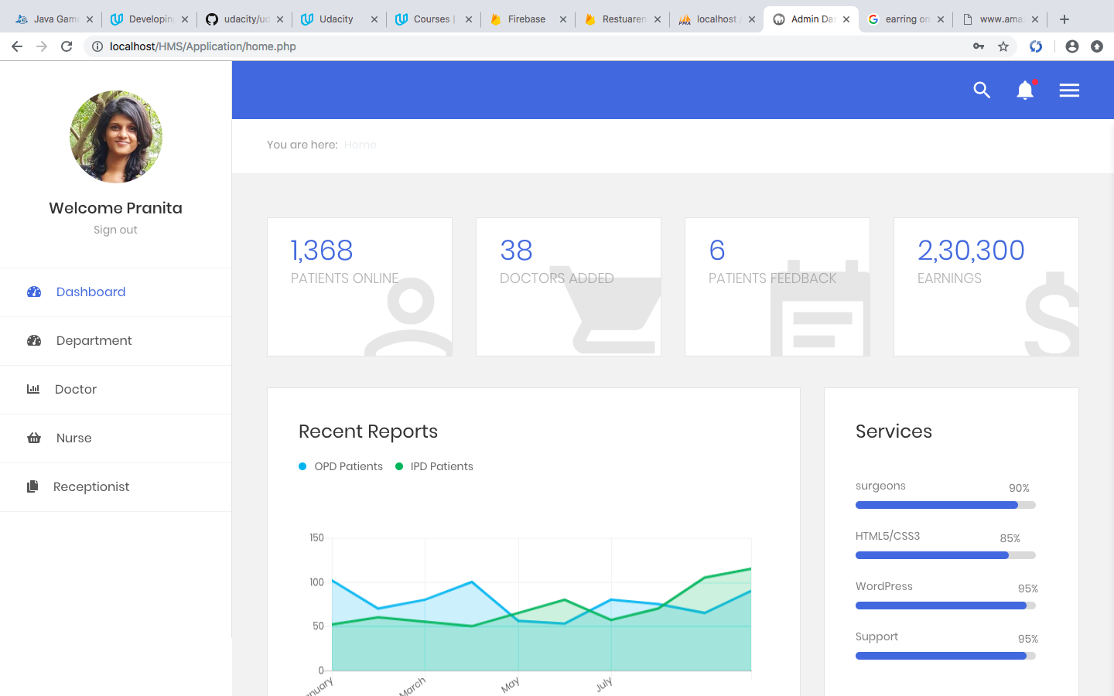

System Management

* 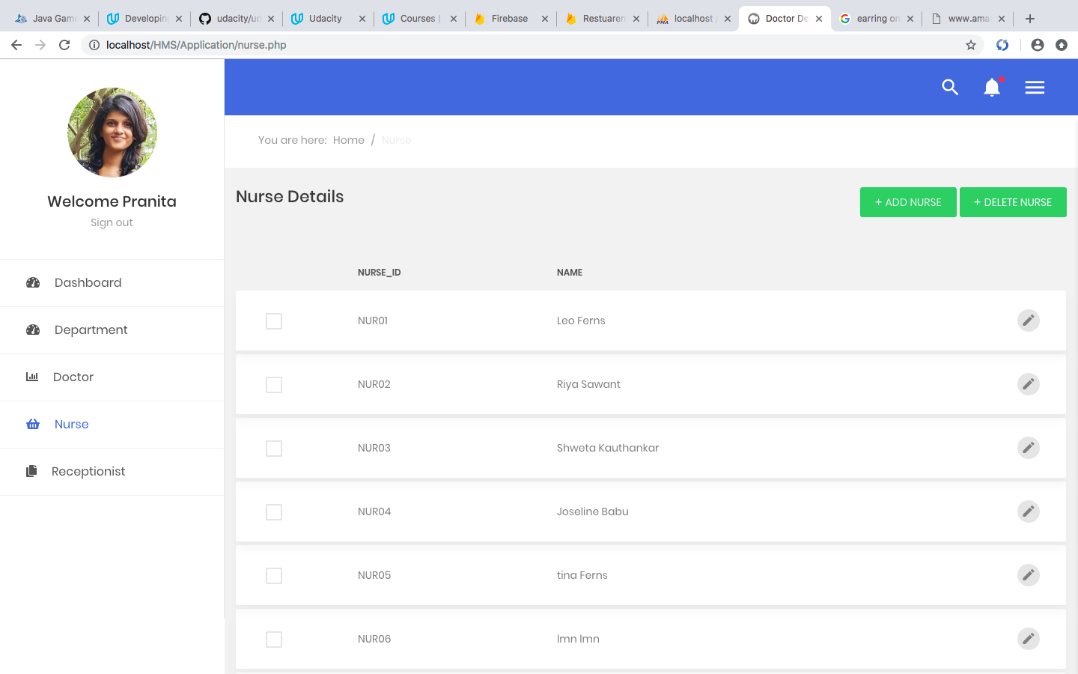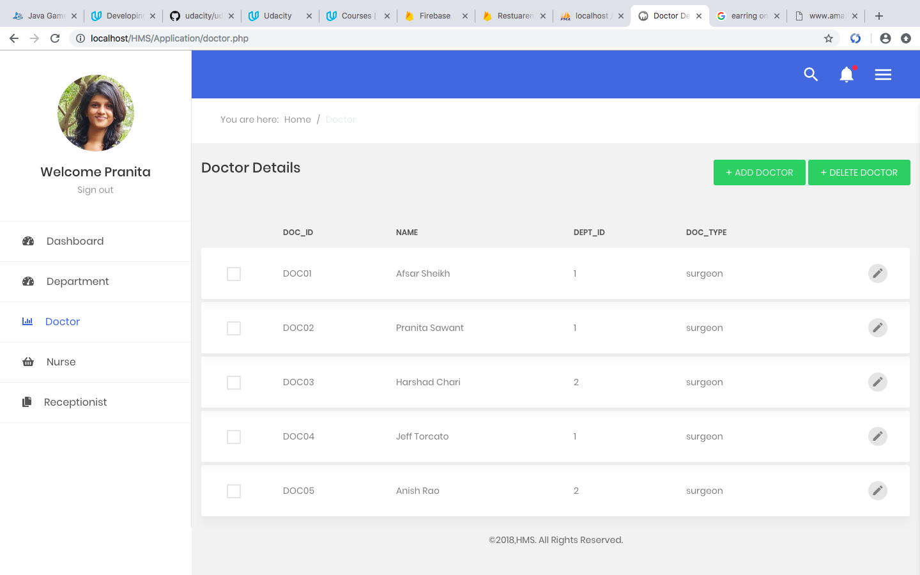Registers staffs.

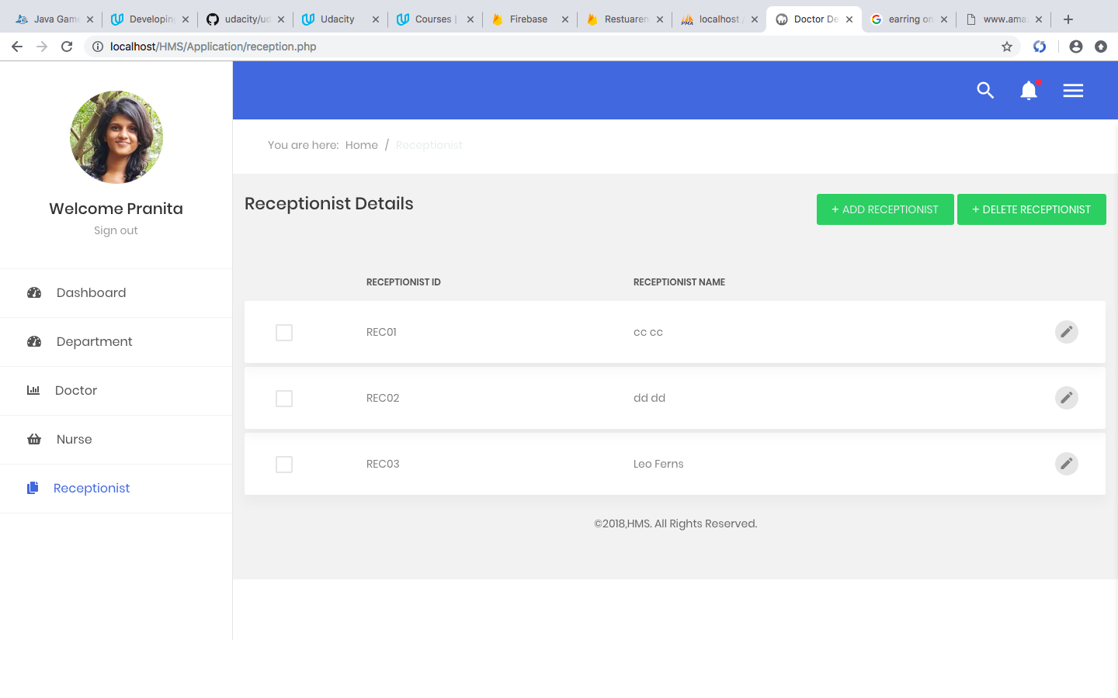

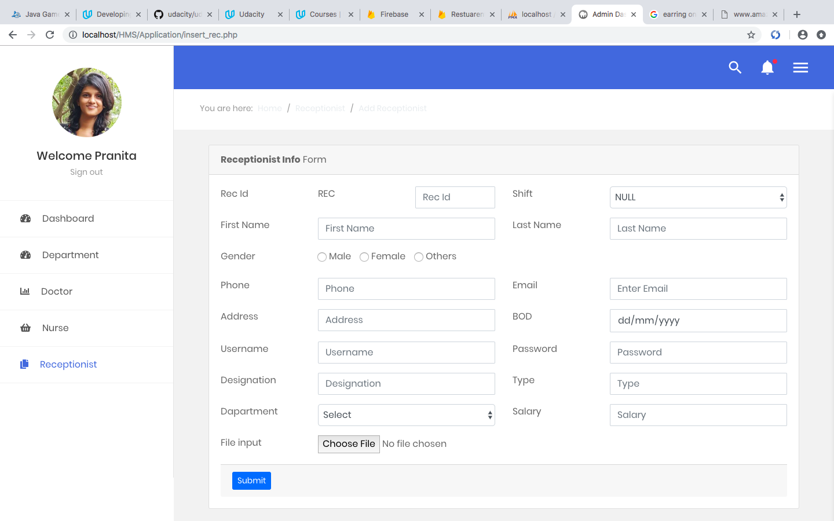

**Staff:**

Staff includes Doctor, Receptionist, Nurse, Lab assistant.

Profile

* Login with the correct login id and password.
* Logout.

Doctor

* Head doctors can create consultation schedule for doctors in 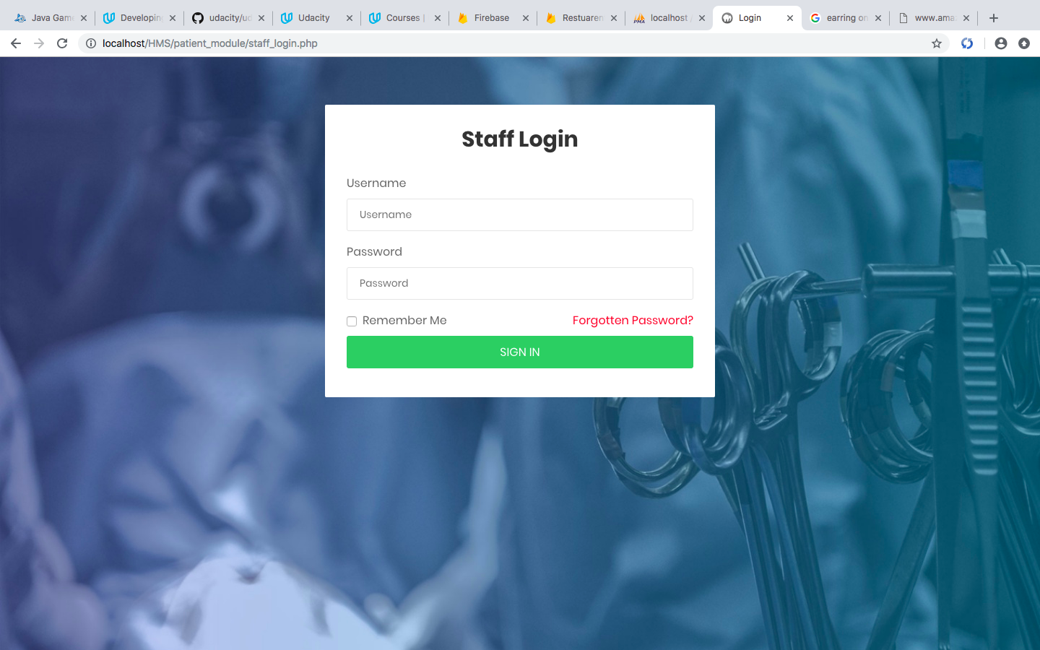its department.

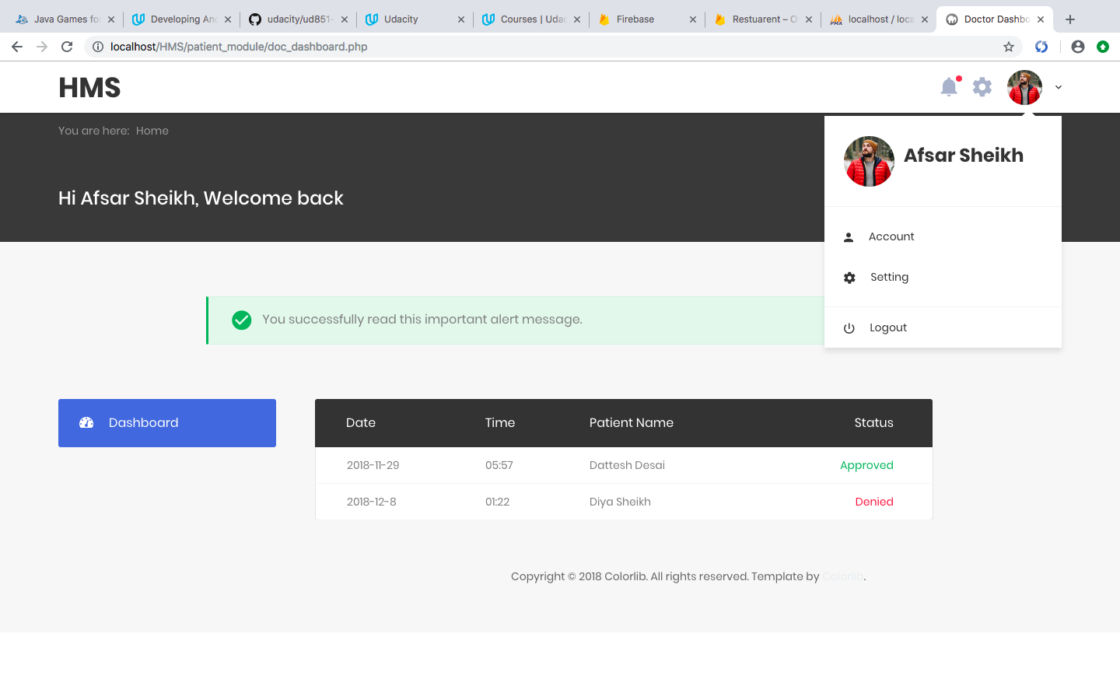

**Patient:**

Profile

* Should login with the correct login id and password.
* Logout.
* Can book new appointment.
* Can view appointment history.

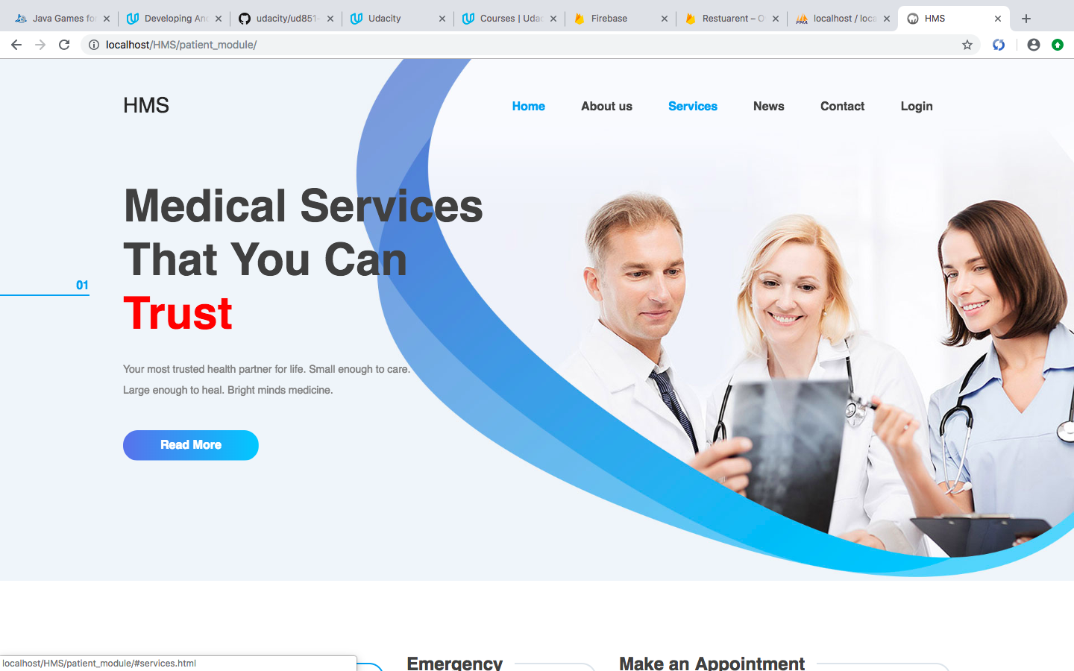

**PATIENT REGISTRATION**

* This module provides vital information for the patient information chart, which marks the outset of demographics capture. This encompasses patient’s name, address and contact information, birth date, employer, and insurance information.
* Unique patient ID for tracking visits
* Supports self registration at the portal.

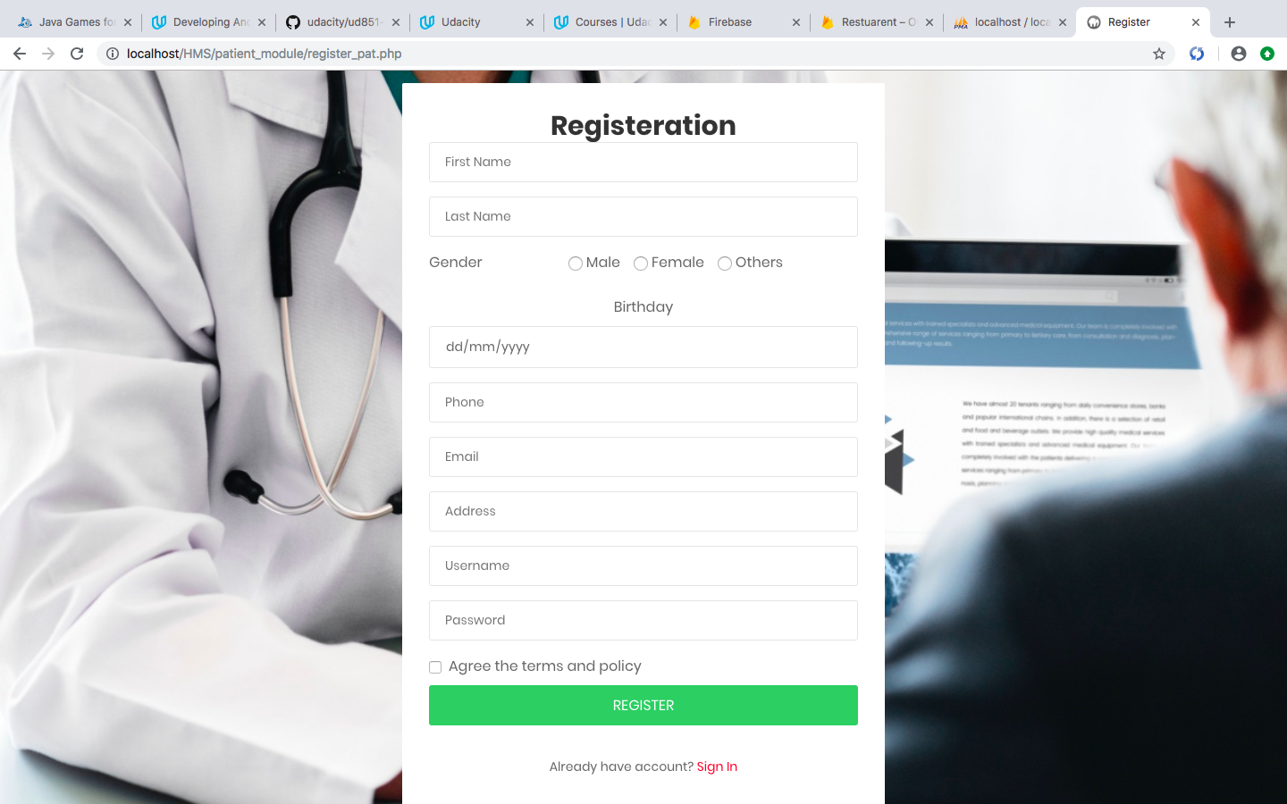

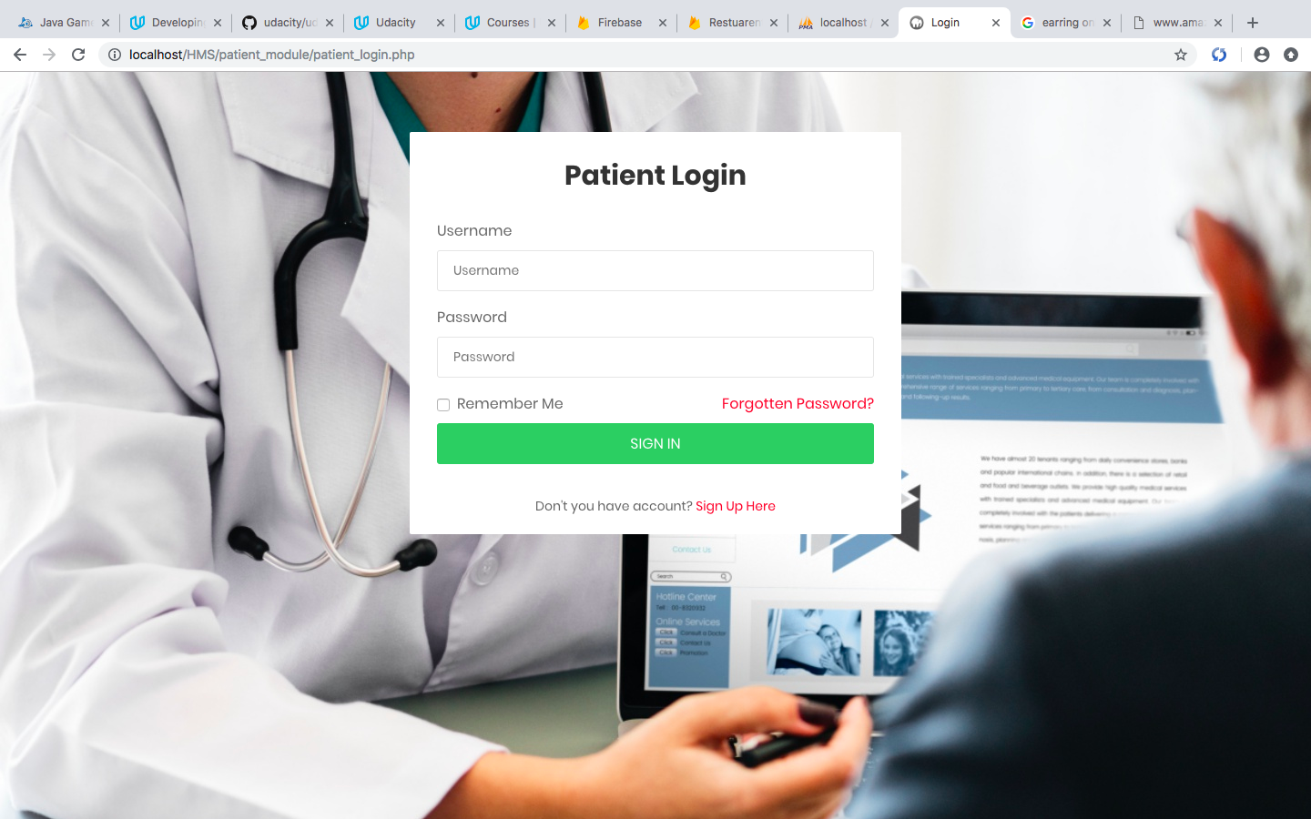

**APPOINTMENT & SCHEDULING**

* This module facilitates effective scheduling of appointments of patients for the doctors.
* Quick and effective patient scheduling
* Online appointment availability
* Patients and staff can check appointment status

